

**Huron Valley robotics team starts season strong**

*7:55 a.m. EDT March 17, 2015*

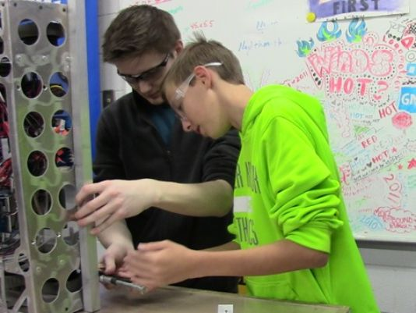

The Huron Valley Schools robotics team kicked off the season strong, winning the Waterford district event on March 6-7.

The HOT (Heroes of Tomorrow) Team joined forces with teams from Oxford and Brighton to win the event.

The robotics team competes in Michigan’s FIRST (For Inspiration and Recognition of Science and Technology) competition, designed to inspire an appreciation of science and technology in young people.

Each year, a different challenge is assigned to schools. Students have several months to build a robot to complete the task, which took place this winter. Competitions started this month with teams putting their mechanical creations to the test in various competitions.

The 2015 game is called Recycle Rush, a recycling-themed game played by two alliances of three robots each. Robots score points by stacking totes on scoring platforms, capping those stacks with recycling containers and properly disposing of pool noodles, representing litter. In keeping with the recycling theme of the game, all game pieces used are reusable or recyclable by teams in their home locations or by FIRST at the end of the season.

In the Waterford district, the HOT Team, which partners with the General Motors Proving Ground, finished the qualification matches ranked first with a 97.41 point qualification average. The average score at the event was 48.77.

Following the qualifiers, the top teams pick two alliance partners to compete in the second half of the competition. In the quarterfinals, The HOT Team alliance produced the highest score in the tournament: 167 points. The team also brought home the Motorola Quality Award, celebrating machine robustness in concept and fabrication.

Members of the Huron Valley team include:

•Robot Driver: Donovan Porter.

•Robot Operator: Rennie Scott.

•Human Player: Nathan Feather.

•Mechanical Pit Crew: Ethan Holper and Kaden Allen.

•Electrical Pit Crew: Julia Zahn and Angela Butkovich.

•Programming Pit Crew: Paul Bonnen and Brandon Mackey.

•Scouting Team: Chad Abou-Hamdan, Ryan Allen, Hunter Barnes, Henry Baxter, Nick Begien. Hunter Beltowski, Marlina Bowring, Melissa Brei, Michael Brown, William Caradonna, Danielle Cummins, John Flowers, Alexis Fosmer, Noah Gould, Shae Grubb, Steven Hagopian, Joseph Hatfield, Alex Iseler, Franklin Jeffery, Cody Kallay, Mallori Kay, Jack Koby, Varun Kutirakulam, Nicklas Lieske, Kirk MacQuarrie-Klender, Dillon Massey, Drew Massey, Riley Morris, Ryan Robinson, Marin Sakuma, Bradley Schoff, Dylan Sellers, Michael Streng, Karel Venegas, Jacob Wheaton and Autumn Whitney.

•Media Team: Noah Beattie, Shawn Blasko, Mary Buzolits, Maddy Dean and Erick Smth.

•Mentors: Spencer Adams, Jason Bretzlaff, Tom Brock, Adam Freeman, Rodney Gleason, Lori Gleason, Ashley Haren, James Hendrickson, Ray Jeffery, Ron Kubani, Ryan Legatto, Jay Meldrum, Jim Meyer, Josh Orlando, Darrel Robinette, Mike Schreiber, Regina Stephenson, Kevin Sweeney, Russ Sweet, Gina Sweet and Marybeth Waldo.

FIRST in Michigan continues to grow with 18 district competitions this year, up from 15 in 2014. The state competition is growing, as well, allowing 102 teams to qualify, double last year’s state finals. The finals, set for April 8-11, will be held at the DeltaPlex Arena in Grand Rapids.

“Our growth in recent years, from 137 teams just five years ago to 347 teams today, has been phenomenal with the combined vision and support of the Michigan governor’s office, local schools wishing to expand STEM opportunities, and students’ passion for learning and preparing more for our global economy,” stated Francois Castaing, chairman of the Board of FIRST in Michigan. “It was important to make sure as our number of teams expand, so do the opportunities for teams to compete locally, and for more teams to qualify for the state championship.”

Huron Valley returns to action March 27-28 at the Livonia Churchill district event.

The International FIRST Championship will take place at the Edward Jones Dome in St. Louis, Mo., April 22-25. Michigan teams have been on the winning alliance at nine of the last 11 national championships. Visit www.usfirst.org, or[www.firstinmichigan.org](http://www.firstinmichigan.org/) for more.